ENGLISH FIRST ADDITIONAL LANGUAGE
GRADE 8
JUNE 2010
PAPER 1
TIME: 1HOUR
MARKS: 40

INSTRUCTIONS AND INFORMATION
- This paper consists of Section A: Comprehension (15)
Section B: Language (25)
- Answer all the questions.
- Leave a line open between each answer.
- Begin the answer to each Section on a NEW page.
- Please remember to write your name at the top of your answer page.
- Write neatly.
- You MAY NOT use tippex.
- If you make a mistuke mistake, draw a line through it and write on.

SECTION A: COMPREHENSION
Read the following passage and answer the questions that follow:

The Man Who Measured Canada
“Never heard of him,” says Leon Charles, a young Cree and guide for our ten-day canoe trip in the Canadian wilderness. We’re bouncing down a dirt road north of Mississippi,
, Saskatchewan, canoes strapped to our van, spewing a plume of dust into the fringe of the primordial forest that once cloaked North America.
David Thompson, I insist, Canada’s most prolific explorer—the fur trader and surveyor who almost single-handedly mapped the nation’s vast, unknown interior 200 years ago. He covered 80,000 miles by foot, horseback, dogsled, and canoe, defining a fifth of the continent, compiling 77 volumes of journals about its geography, biology, and ethnography. Equipped only with a brass sextant and a courageous heart, he made maps that rival images gleaned from today’s satellites. He was, some think, the world’s greatest land geographer.
Leon shrugs politely. This “white man’s history” rings no bells.
Thompson, I tell him, made Lewis and Clark look like tourists. He should be one of Canada’s most heroic figures. But “David who?” is what I often heard as I followed Thompson’s restless life. No good biography, no photograph, not even a painting exists of the man. A smallish western river, a lonely highway, a town in Montana bear his name, but little else.
It’s true that Canada does not readily fashion heroes. Its founders were those who refused to rebel. Its westward march was orderly, fueled by business opportunities, not buccaneering passion as in the United States. Native Americans were colleagues in the fur business, not obstacles to expansion. There were no six-guns, no massacres, no Davy Crocketts.
“Thompson’s sin was that he was only successful,” Ian MacLaren, a professor of Canadian studies at the University of Alberta, told me. “There was no disaster, no horror story. He wouldn’t have made good TV.”
Yet Thompson was the quintessential North American, a “mapmaker of the Canadian mind,” as Victor Hopwood, a Vancouver scholar, says. He was an intellectual nurtured in the wilderness, a man who served the British scientist’s eccentric obligation to bring order to the unknown, but he was humbled by the spirit and grandeur of the land.
At least some of Thompson’s anonymity was his own doing. He was a difficult man who took satisfaction in being the outsider—a white man among Indians, a Welshman among Scots, a pious man among the colorfully profane French voyageurs. He disdained the spotlight and discouraged casual friendships. He was no self-promoter, and thus when he wrote the narrative of his life, his Travels, he could find no publisher.
Microsoft ® Encarta ® 2006. © 1993-2005 Microsoft Corporation. All rights reserved.

  - How many days will they spend in the Canadian Wilderness?
(1)
1.2 What kind of vehicle are they travelling with in the first paragraph?
(1)
1.3 What is David Thompson famous for?
(1)
1.4 How many books did David Thompson write about Canada?
(1)
1.5 How many years ago did David Thompson travel across Canada?
(1)
1.6 What equipment did David Thompson use. Mention two things.
(2)
1.7 Quote a sentence which shows that Leon has never heard of David Thompson.
(1)
1.8 Quote a sentence which shows people don’t know what David Thompson looks like.
(1)
1.9 What in Canada is named after David Thompson?
(1)
1.10 What is the name of the story that David Thompson wrote about his own life?
(1)
1.11 Say whether the following statement is TRUE or FALSE. Quote a sentence to give a reason for you answer.

Canada builds huge statues for its heroes.
(2)
1.12 Say whether the following statement is TRUE or FALSE. Quote a sentence to give a reason for your answer.

Thompson did not like to be in the spotlight, he did not like to be known by everyone.
(2)
1.13 Is there a good biography written about the life of David Thompson. Answer YES or NO.
(1)
[15]
SECTION B: LANGUAGE
QUESTION 2
CARTOON
Look at the following cartoon and answer the questions that follow:
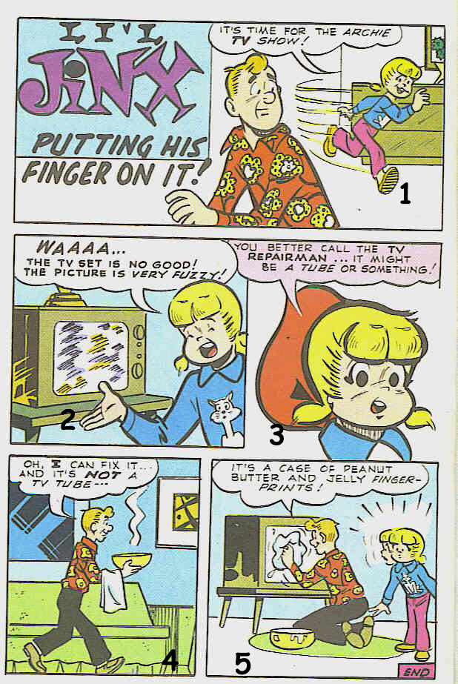

2.1 Why is the little girl running in frame 1?
(1)
2.2 What is the meaning of the word “fuzzy” in frame 2?
(1)
2.3 What does the expression “WAAA…” mean?
(1)
2.4 What does the little girl think is wrong with the TV?
(1)
2.5 TV is an abbreviation. Write out the word in full.
(1)
2.6 The man in frame 4 carries two things. What is he carrying?
(2)
2.7 What was wrong with the TV?
(1)
2.8 Who do you think is guilty of touching the TV screen?
(1)
[9]
Look at the following Advertisement and answer the questions that follow:

2.9 What must you lick?
(1)
2.10 What is this advertisement advertising?
(1)
2.11 Why is this a good advertisement? Give two reasons.
(2)
2.12 How many flavours does this product have?
(1)
2.13 What would you say when you taste one of the product?
(1)
[6]
The following reading passage has some deliberate mistakes in them. Read the passage and answer the questions that follow:

Oil from the big leak in the Gulf of Mexico has started to wash up on nearby islands in southern America.
- Pelicans and other birds covered in oil (has/have) been found on the uninhabited Chandeleur (ailands/islands), which are part of a big national wildlife area.

- Meanwhile workers (has/have) started lowering a giant funnel over the leaking oil well at the bottom of the sea.

- Remote-controlled submarines are being used to lower the 90-tonne box in an operation (ecspected/expected) to take two days.

- It will trap the oil and then send it to the surface in pipes so ships can collect it.
- But the effects on wildlife in the area are starting to be seen.

- Authorities have desperately been trying to stop the oil heading towards land but (its/ it's ) finally starting hit shorelines.

2.14 Should you use has or have in sentence 1 of the passage?
(1)
2.15 Which spelling is correct in sentence 1 … ailands or islands?
(1)
2.16 Should you use has or have in sentence 2 of the passage?
(1)
2.17 What do you call the punctuation mark used in the word (Remote-controlled) in sentence 3?
(1)
2.18 Look at sentence 3. Which word is spelled correctly: ecspected or expected?
(1)
2.19 Change sentence 4 into a question. Begin the question with: Will it…
(4)
2.20 Look at sentence 6. Must you use its or it’s?
(1)
[25]
Grand total of paper: 40

